WEEK 2
DATASET INSPECTION
& DATA QUALITY ASSESSMENT
Project: Exploring Customer Feedback and Product Sentiment
Student Name: Sumit Kumar
Internship: Data Science with Python Analyst Internship
Project Domain: Beauty and Wellness
Dataset: Amazon Beauty Reviews (amazon_beauty_reviews_dataset.csv)
Submission Date: 09 October 2026
Tools: Python, pandas, Visual Studio Code
WEEK 2 SUBMISSION REPORT

1. Introduction
This report documents Week 2 dataset inspection and initial data-quality assessment for the Beauty and Wellness project, “Exploring Customer Feedback and Product Sentiment.” The selected file, amazon_beauty_reviews_dataset.csv, was inspected using a Python script in Visual Studio Code.
The work focused on confirming that the dataset could be read, reviewing its structure and data types, checking missing values, and performing basic validation of review ratings and timestamps. These are initial inspection results; no sentiment classification or predictive model was performed.

2. Dataset Overview
The dataset was located in the project directory at data/raw/amazon_beauty_reviews_dataset.csv. The inspection output reported 70,528 records and 10 columns. The script read a small sample first, displayed the first five rows, and then processed the file in chunks for full-dataset checks.
Dataset property | Observed result
File name | amazon_beauty_reviews_dataset.csv
Location | data/raw/
Total records | 70,528
Total columns | 10
Inspection method | pandas; chunk size 5,000 for data-quality checks

3. Dataset Columns and Data Types
The inspection identified the following fields and reported data types:
Column | Data type
rating | int64
title | str
text | str
images | str
asin | str
parent_asin | str
user_id | str
timestamp | str
helpful_vote | int64
verified_purchase | bool
The fields include review ratings and text, product identifiers, user identifiers, timestamps, helpful-vote counts, and verified-purchase status. The timestamp is stored as text in the inspected dataset and was separately checked for parseability.

4. Missing-Value Assessment
The full inspection reported missing values in two fields: 160 missing values in title and 212 in text. The other eight columns had zero missing values in the output. The reported rounded percentages were approximately 0.02% for title and 0.03% for text.
Column | Missing values | Approx. share
title | 160 | 0.02%
text | 212 | 0.03%
All other columns | 0 each | 0.00%
Missing review titles and text should be handled deliberately during preprocessing. For text-based sentiment work, records without review text may need to be excluded from that specific analysis, while retaining them for other suitable summaries where appropriate.

5. Data-Quality Checks
The script reported 716 duplicate rows detected within the chunks processed. Because the code checks duplicates within individual chunks, this figure should be treated as a within-chunk duplicate count; it does not establish a global duplicate count across the entire file.
The rating distribution reported by the script was:
Rating | Number of records
1 star | 10,280
2 stars | 4,304
3 stars | 5,607
4 stars | 7,931
5 stars | 42,026
Total | 70,528
The sum of rating counts matched the reported total number of rows. The script detected zero ratings outside the 1–5 range and zero timestamps that failed parsing with the selected pandas datetime conversion.

6. Methodology
- Located the CSV file under data/raw and verified that the path existed.
- Loaded a five-row sample to inspect representative records and column names.
- Reviewed column data types and the sample shape.
- Calculated missing-value counts and percentages.
- Processed the CSV in chunks of 5,000 rows to count records, within-chunk duplicates, rating frequencies, out-of-range ratings, and unparseable timestamps.
- Compared the sum of rating frequencies with the total row count as a consistency check.

7. Key Findings
- The dataset was successfully found and read by the inspection script.
- The inspected file contains 70,528 rows and 10 columns.
- Missing values were limited to title (160) and text (212) in the reported output.
- All observed ratings fell within the expected 1–5 range.
- No timestamps were reported as unparseable by the script.
- The script counted 716 within-chunk duplicate rows; a full-file duplicate check may be needed before deciding which records to remove.

8. Screenshot Evidence
The following screenshots document the dataset inspection process and console output. They are supporting evidence for the reported results.
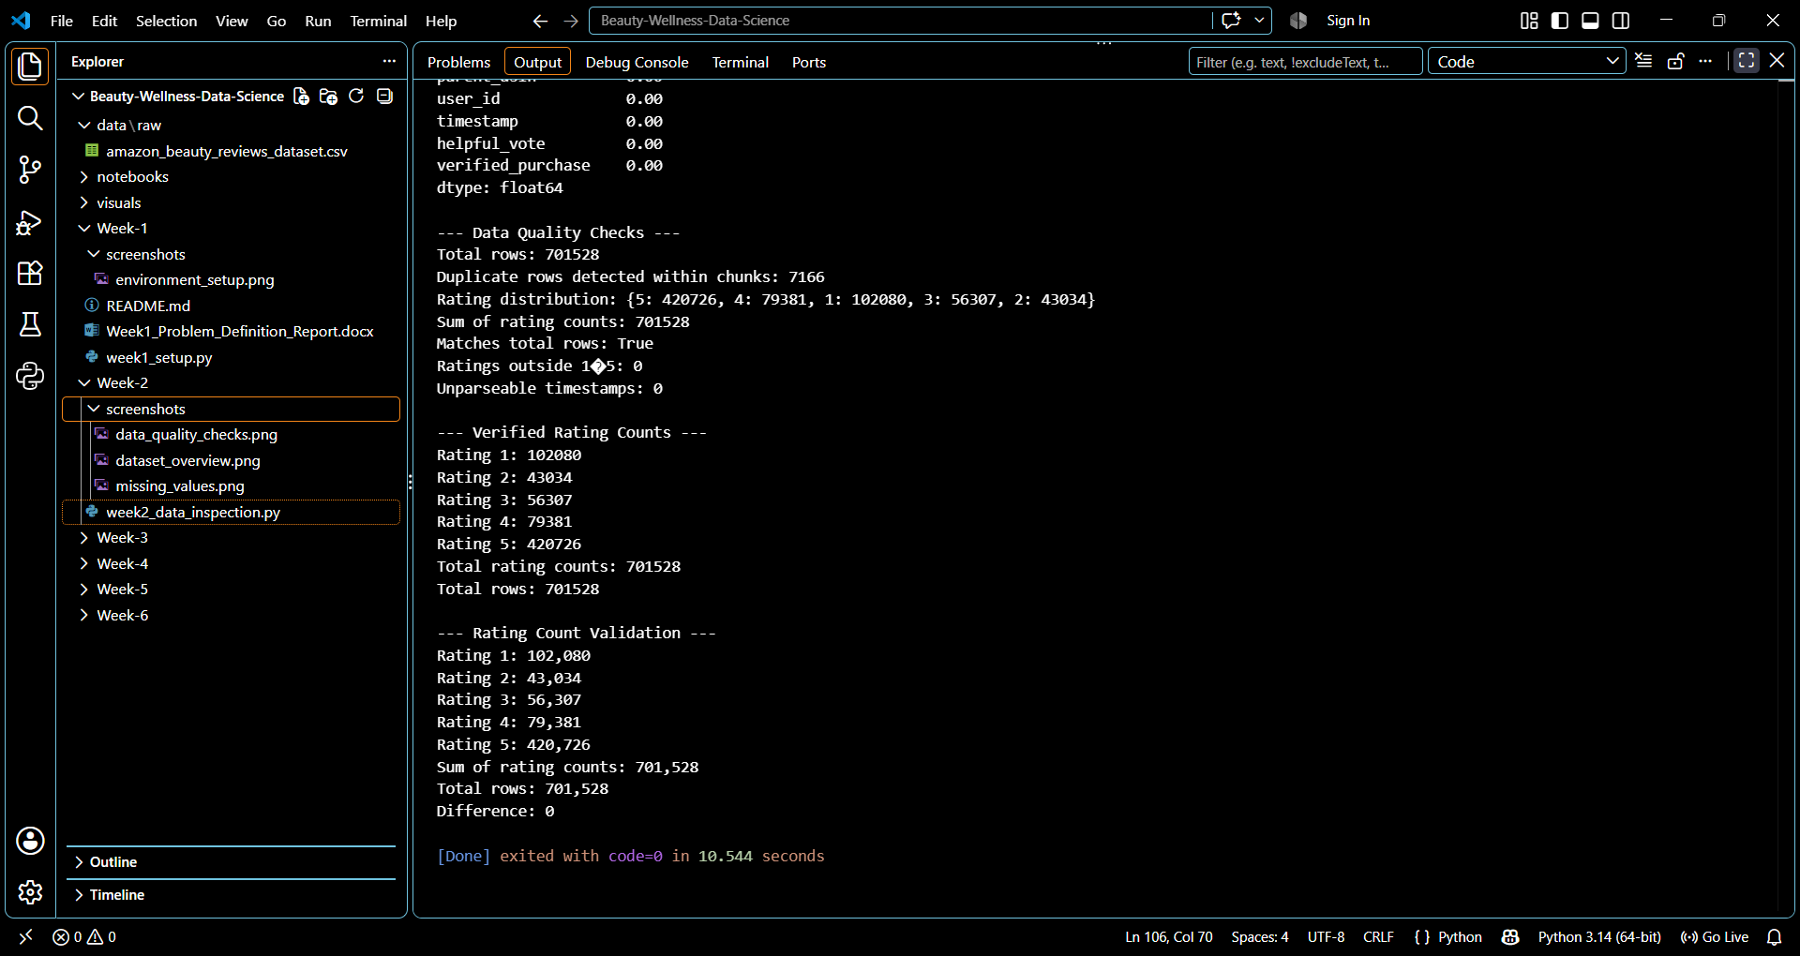
Figure 1. Dataset inspection output showing sample information, column names, data types, and sample shape.
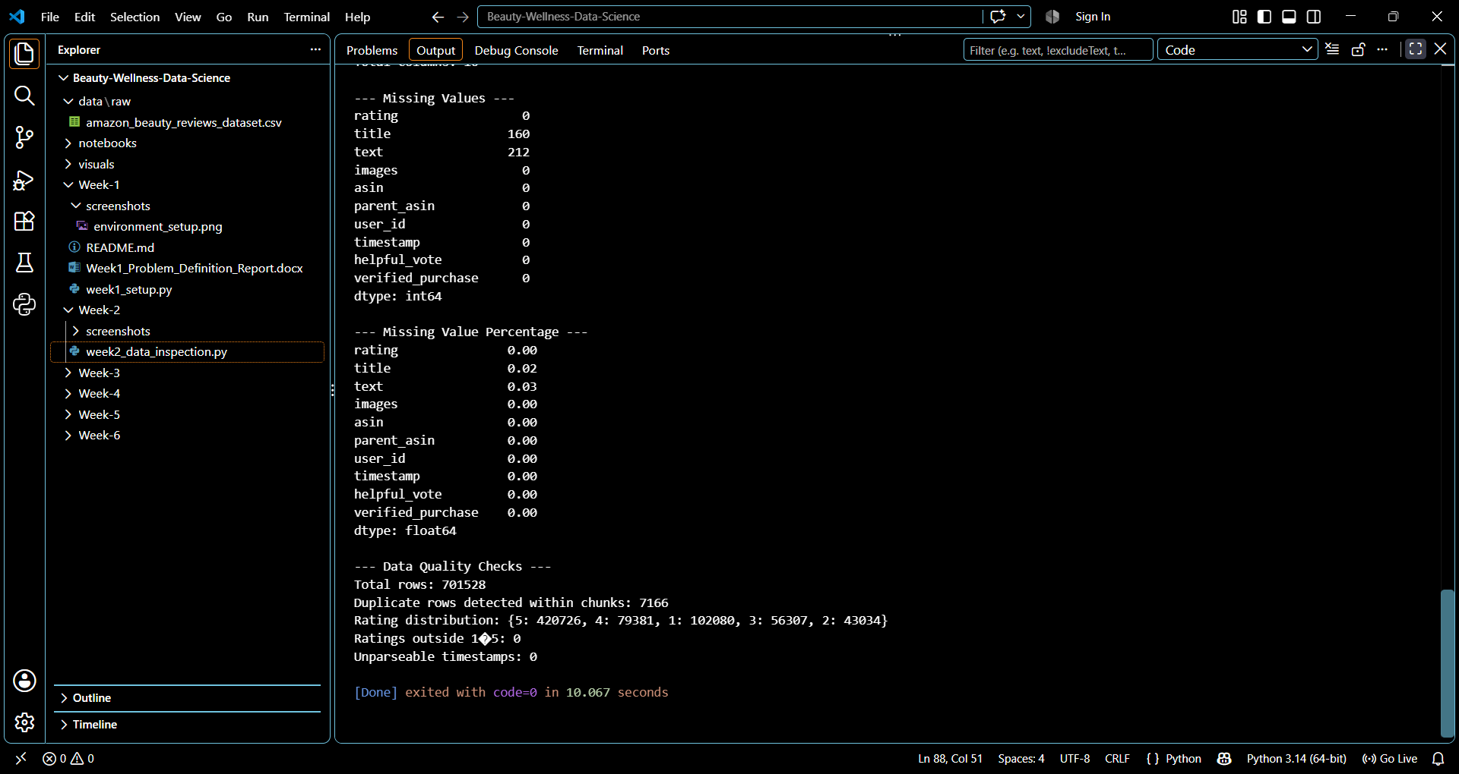
Figure 2. Console output showing missing-value counts and percentages.
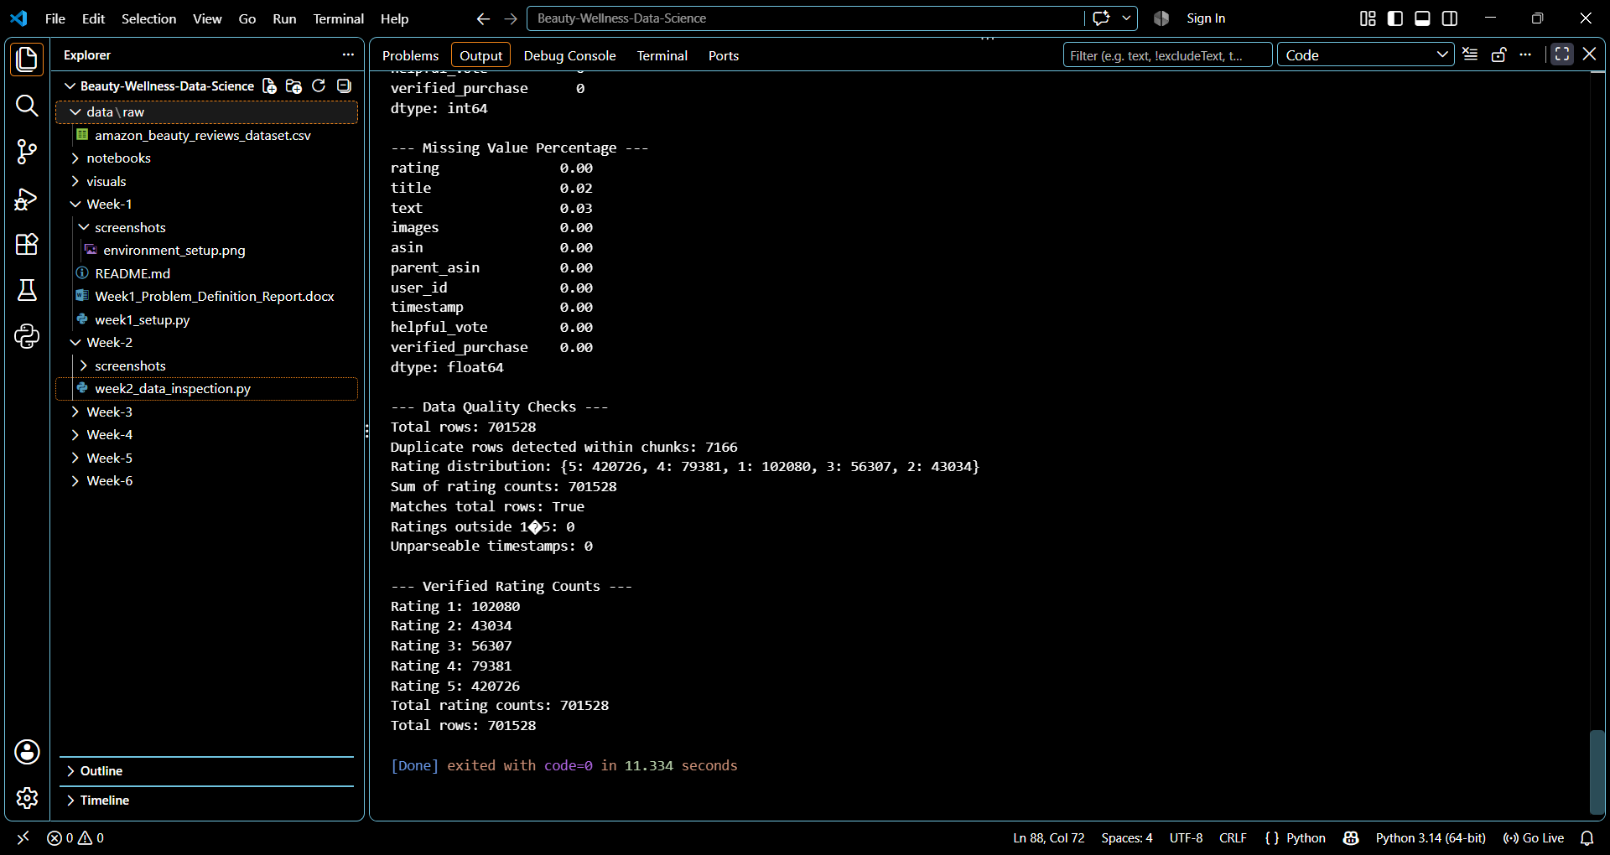
Figure 3. Data-quality validation output, including rating counts and consistency checks.

9. Tools and Technologies
- Python 3.14.6
- pandas 3.0.6
- Visual Studio Code
- CSV dataset processed with pandas

10. Week 2 Deliverables
- Dataset inspection script (Week-2/week2_data_inspection.py).
- Raw dataset file (data/raw/amazon_beauty_reviews_dataset.csv).
- Screenshot evidence in Week-2/screenshots/ (dataset_overview.png, missing_values.png, data_quality_checks.png).
- Week 2 dataset inspection and data-quality report.

11. Limitations and Next Steps
This stage was limited to structural inspection and selected data-quality checks. The reported duplicate count is scoped to within-chunk checks and should not be interpreted as a complete global duplicate assessment. Missing values have been identified but not yet imputed, removed, or otherwise transformed.
Next steps are to document dataset provenance and permitted use, decide on a reproducible duplicate-handling strategy, inspect review-text quality, and prepare a cleaned analysis dataset before exploratory analysis or sentiment exploration.

12. Conclusion and Data Provenance
Week 2 successfully established the dataset’s basic structure and documented initial data-quality observations. The results provide a starting point for preprocessing and exploratory analysis, while keeping data limitations explicit.
The dataset file used in this work is named amazon_beauty_reviews_dataset.csv. Its original source, license, and collection documentation were not established by the inspection screenshots or script output reviewed for this report; these details should be added to the repository when verified.

